Thanksgiving Dishes | Put Away School Things | List 3 | List 4
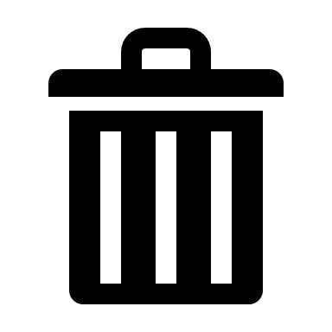 Wednesday: Trash | Check for Eggs
Summer Items to Attic | Charge Nightlight
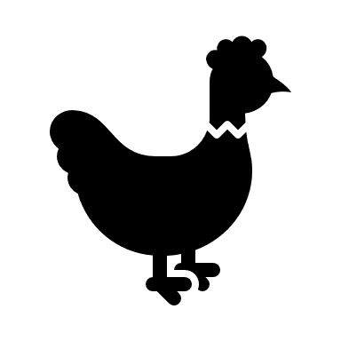 Fill Chicken Bucket | Help with Dinner
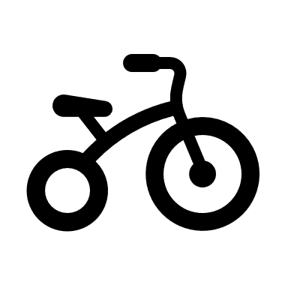 Hang up Bikes | Pick up Toys
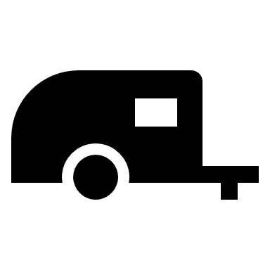 Put Away Trailer | Bath
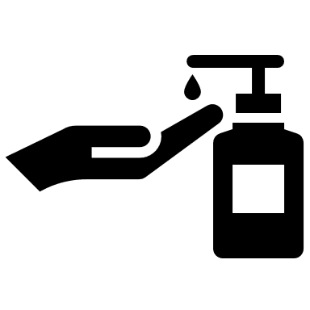 Fill All Soaps | Laundry in Basket
Move Heaters | Feed Cato
Snowpants | Brush Teeth/Hair
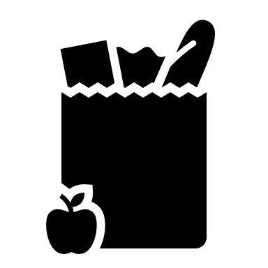 Costco | Reading

